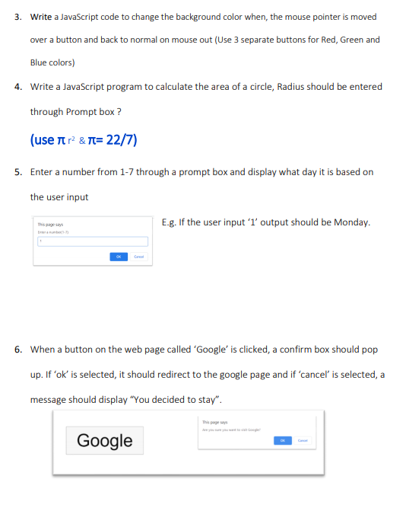**Name : E W V Pesara ID - 26708**

**JavaScript - Tutorial**

Exercise 05

<html>

<body>

<script>

function getDayOfWeek()

{

var input = parseInt(prompt("Enter a number from 1 to 7:"));

if (isNaN(input) || input < 1 || input > 7) {

alert("Invalid input! Please enter a number from 1 to 7.");

return;

}

var daysOfWeek = [

"Sunday",

"Monday",

"Tuesday",

"Wednesday",

"Thursday",

"Friday",

"Saturday"

];

var dayName = daysOfWeek[input - 1];

alert("The day is: " + dayName);

}

getDayOfWeek();

</script>

</body>

</html>

Exercise 06

<html>

<body>

<button id="googleButton">Google</button>

<script>

document.getElementById('googleButton').addEventListener('click', function() {

var result = confirm("Do you want to go to Google?");

if (result) {

window.location.href = "https://www.google.com";

} else

{

alert("You decided to stay.");

}

});

</script>